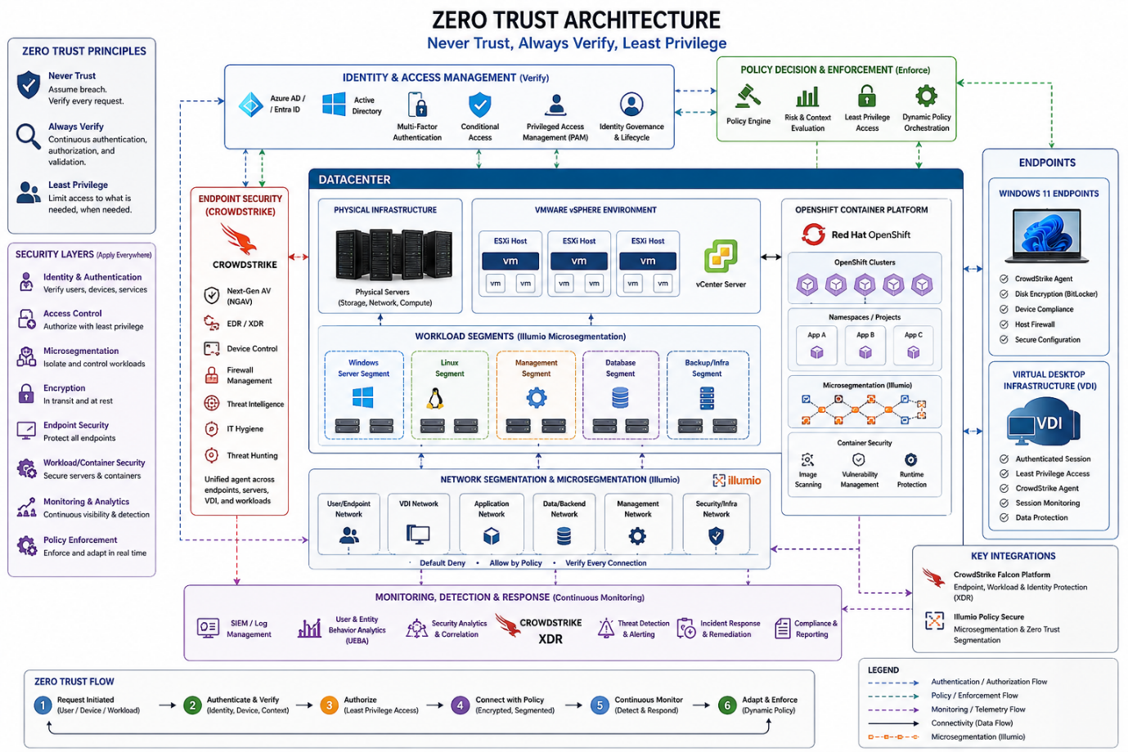

Here's a breakdown of how the diagram is structured across its seven zones:
Identity & Policy Control Plane (top) — Every access decision flows through here first. The Identity Provider handles MFA and SSO, PAM/Vault manages secrets and RBAC, and the Policy Engine (OPA) enforces attribute-based rules. The SIEM/SOAR layer receives telemetry from every other zone.
Network Security Layer — The ZTNA Gateway replaces traditional VPN with app-level access. Next-gen firewalls do deep packet inspection, microsegmentation controls east-west traffic between workloads, and an encrypted fabric (mTLS/IPSec/WireGuard) ensures all data-in-transit is protected. WAF, NAC, and DNS filtering sit beneath this.
Datacenter zone (left) — Physical servers with TPM/secure boot feed into VMware ESXi/vCenter/NSX-T. Windows Server and Linux systems are hardened with GPO, SELinux, and CIS benchmarks. A microsegmentation boundary separates this zone from OpenShift.
OpenShift Container Platform (right) — The OCP control plane enforces RBAC at the API level. Worker nodes run CRI-O with cgroup v2. Istio service mesh enforces mTLS between pods, Kyverno/Falco handle pod security policies, and all images are signed and scanned in the registry.
Continuous Monitoring band — Sits between infrastructure and endpoints, aggregating EDR telemetry, runtime threat detection, posture assessments, and behavioral analytics back up to the SIEM.
Endpoint zone — Windows 11, macOS, VDI (Horizon/Citrix), and mobile devices all run EDR/XDR agents, are validated for compliance before access is granted, and connect only through ZTNA client agents with device certificates.
Auth flow & re-verification loop (bottom) — Shows the six-step cycle: Request → Authn → Authz → Encrypt → Access → Log, with a continuous re-verification feedback loop so no session is permanently trusted.
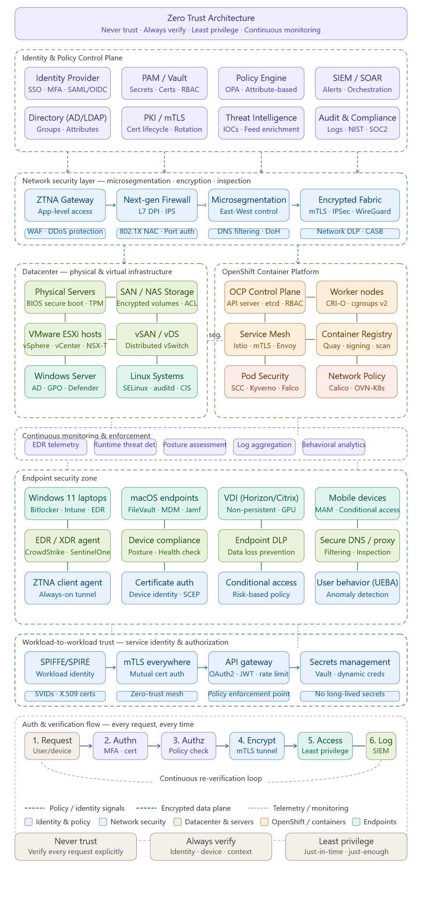Below is a detailed ASCII-based **Zero Trust Architecture diagram** that includes all requested components, logical groupings, and interactions. The diagram illustrates how Zero Trust principles (never trust, always verify, least privilege) are applied across layers, with clear flows for authentication, authorization, continuous monitoring, and microsegmentation.

---

## Zero Trust Architecture Diagram (ASCII Art)

```
+========================================================================================================+
| ZERO TRUST CONTROL PLANE |
| +------------------+ +------------------+ +------------------+ +------------------+ |
| | POLICY ENGINE |<---->| POLICY ADMIN |<---->| POLICY ENFORCEMENT| | CONTINUOUS | |
| | (PE) | | (PA) | | POINT (PEP) | | MONITORING (SIEM)| |
| | - Access decisions| | - Policy creation| | - Gateway/proxy |<---->| - Log aggregation| |
| | - Risk scoring | | - Audit logs | | - Micro-seg. ctrl | | - Anomaly detect | |
| +------------------+ +------------------+ +------------------+ +------------------+ |
| ^ ^ ^ ^ |
| | | | | |
| | (Authentication, AuthZ) | (Policy push) | (Policy enforcement) | (Security data) |
| | | | | |
+=========|============================|=========================|=========================|================+
| | | |
v v v v
+------------------+ +------------------+ +------------------+ +------------------+
| IDENTITY & |<---->| DATACENTER |<---->| CONTAINER |<---->| ENDPOINTS |
| ACCESS MGMT (IAM)| | (Physical + VM) | | PLATFORM (OCP) | | (Win11 + VDI) |
+------------------+ +------------------+ +------------------+ +------------------+
| • Azure AD/Okta | | • Physical servers| | • OpenShift nodes | | • Win11 laptops |
| • MFA / passwordless| | • VMware ESXi | | • Pods & services | | • VDI pool |
| • Conditional access| | • Win/Linux VMs | | • Network policies| | • Endpoint agents |
| • Just-in-time priv| | • Host firewalls | | • Istio/ServiceMesh| | • EDR/AV |
+------------------+ +------------------+ +------------------+ +------------------+
| | | |
| (TLS + mutual auth) | (TLS + mTLS) | (TLS + mTLS) | (TLS + mutual auth)
v v v v
+------------------+ +------------------+ +------------------+ +------------------+
| NETWORK SEGMENTATION & MICROSEGMENTATION |
| +------------------+ +------------------+ +------------------+ +------------------+
| | Edge Firewall |<---->| Workload Firewall| | Container CNI |<---->| Endpoint Firewall |
| | (East-West, | | (ESXi + VMs) | | (Calico/Cilium) | | (Windows Defender)|
| | North-South) | | - vSphere NSX | | - Network policies| | - Host firewall |
| +------------------+ +------------------+ +------------------+ +------------------+
| | | |
| (IPsec/ESP) | (VLAN/VXLAN) | (Overlay) | (TLS/HTTPS)
v v v v
+------------------+ +------------------+ +------------------+ +------------------+
| ENCRYPTION LAYER |<---->| STORAGE & DATA |<---->| API GATEWAY |<---->| REMOTE ACCESS |
| (At rest, in trans)| | (LUKS, BitLocker)| | (OAuth2, JWT) | | (ZTNA, SDP) |
+------------------+ +------------------+ +------------------+ +------------------+

Legend:
<----> : Logical interaction / bidirectional data flow
-----> : Authentication/authorization request
v : Data plane traffic (encrypted)
^ : Control plane feedback / monitoring data
[ ] : Security layer or infrastructure component
+---+ : Grouping / boundary
```

---

## How Zero Trust Principles Apply Across Each Layer

| Layer / Component | Zero Trust Implementation |
|-------------------|----------------------------|
| **Identity & Access Management** | Continuous verification of user/device identity (MFA, risk-based conditional access). Least privilege via just-in-time (JIT) access and role-based access control (RBAC). |
| **Datacenter (ESXi + Windows/Linux)** | Host-level firewalls (Windows Defender Firewall, iptables). Application control (AppLocker, SELinux). Microsegmentation using vSphere NSX to isolate VMs even within same ESXi host. |
| **OpenShift Container Platform** | Network policies (Calico/Cilium) to restrict pod-to-pod communication. Service mesh (Istio) with mTLS and fine-grained authorization policies. Pod Security Standards (PSS) and admission controllers. |
| **Endpoints (Win11 laptops, VDI)** | Device health attestation (Microsoft Intune / Conditional Access). Endpoint detection and response (EDR) with continuous monitoring. Host firewalls and app isolation (Windows Defender Application Guard). |
| **Network Segmentation** | Zero Trust assumes no implicit trust between any segments. East-West firewalls (next-gen firewall with IDS/IPS) between all workload groups. Overlay networks (VXLAN) with cryptographically separate tunnels. |
| **Encryption** | All data in transit encrypted with TLS 1.3, mutual TLS for service-to-service, IPsec for site-to-site. At rest: BitLocker (Windows), LUKS (Linux), OpenShift encrypted storage classes. |
| **Monitoring & Policy Enforcement** | SIEM aggregates logs from all components (Windows Event Logs, Linux Syslog, OpenShift audit logs, endpoint EDR). The Policy Engine (PE) continuously evaluates risk scores and triggers re-authentication or policy changes. |

---

## Interaction Flows (Authentication, Authorization, Monitoring)

```
+----------------+ +----------------+ +----------------+
| Endpoint |----->| Identity |----->| Policy Engine |
| (Win11 laptop)| (1) | Provider (Okta)| (2) | (PE) |
+----------------+ +----------------+ +----------------+
| | |
| (2a) AuthZ token | (3) Policy decision |
v v v
+----------------+ +----------------+ +----------------+
| PEP (Gateway) |<---->| Target Resource| | SIEM |
| (ZTNA, API GW)| (4) | (VM, Pod, App)|----->| (Logs, Alerts)|
+----------------+ +----------------+ +----------------+
| |
| (5) Continuous monitoring | (6) Threat detection
| (EDR, agent telemetry) | (anomaly → re-evaluate)
v v
+----------------+ +----------------+
| Policy Admin |<-----| Security |
| (PA) | (7) | Orchestration |
+----------------+ +----------------+
```

**Steps:**
1. Endpoint authenticates to IAM (MFA, device compliance).
2. IAM issues token (JWT) after evaluating identity + device + context.
3. Request to access resource passes through PEP (e.g., ZTNA gateway). PEP queries PE for decision.
4. PE grants/denies access (least privilege, just enough). PEP enforces (e.g., permit/deny, microsegment).
5. Traffic flows encrypted (mTLS) between endpoint and target resource.
6. All components send telemetry (logs, metrics) to SIEM continuously.
7. SIEM detects anomalies → triggers PA to update policies → PE pushes new rules to PEP and firewalls.

---

## Logical Grouping and Network Segmentation

```
[INTERNET / UNTRUSTED]
|
v
+------------------+ +------------------+
| EDGE SEGMENT | | PUBLIC CLOUD |
| • ZTNA gateway | | (if applicable) |
| • DDoS / WAF | +------------------+
+------------------+
|
| (IPsec tunnel, mutual TLS)
v
+-----------------------------------------------------------------------+
| INTERNAL NETWORK (ZERO TRUST ZONES) |
| +--------------------+ +--------------------+ +--------------------+ |
| | ZONE 1: IDENTITY | | ZONE 2: WORKLOADS | | ZONE 3: CONTAINER| |
| | (IAM, AD, MFA) | | (Windows/Linux) | | (OpenShift) | |
| +--------------------+ +--------------------+ +--------------------+ |
| | • Azure AD | | • ESXi hosts | | • OCP master | |
| | • Conditional Acc.| | • VM firewalls | | • Worker nodes | |
| | • PIM (Privileged)| | • AppLocker/SELinux| | • Istio mTLS | |
| +--------------------+ +--------------------+ +--------------------+ |
| | | | |
| v v v |
| +--------------------+ +--------------------+ +--------------------+ |
| | ZONE 4: ENDPOINTS | | ZONE 5: DATA | | ZONE 6: MGMT | |
| | (Win11, VDI) | | (Storage, DB) | | (SIEM, PA, PE) | |
| +--------------------+ +--------------------+ +--------------------+ |
| | • EDR agents | | • Encrypted volumes| | • Log collectors | |
| | • BitLocker | | • Database firewall| | • Policy engines | |
| | • Host firewall | | • Data masking | | • Orchestration | |
| +--------------------+ +--------------------+ +--------------------+ |
+-----------------------------------------------------------------------+
| | |
v v v
+------------------+ +------------------+ +------------------+
| DEDICATED | | BACKUP / DR | | SECURITY |
| NETWORK SEGMENT | | (isolated VLAN) | | SEGMENT |
| (VPN, Jump host)| | (immutable copy)| | (SOAR, Honeypot)|
+------------------+ +------------------+ +------------------+
```

**Key segmentation rules:**
- **North-South traffic** passes through ZTNA gateway → PEP → microsegmented internal zones.
- **East-West traffic** is blocked by default except as allowed by explicit policies (firewall rules, network policies).
- **Workloads** (VMs, pods) cannot talk to endpoints or the Internet directly; all traffic must go through PEP or service mesh proxies.
- **Management zone** (SIEM, PE, PA) is isolated with strict RBAC, JIT access, and multi-factor authentication for any administrative action.

---

## Integration of Security Layers

| Security Function | How It Integrates Across All Components |
|------------------|------------------------------------------|
| **Identity** | IAM (Azure AD/Okta) provides authentication for users (endpoints) and service accounts (VMs, pods). Token (JWT) is passed through PEP and validated at each resource. |
| **Access Control** | Policy Engine evaluates context (device health, location, user behavior) and returns decision. PEP (Gateway, API Gateway, Envoy sidecar) enforces on each request. |
| **Microsegmentation** | vSphere NSX on ESXi separates VMs; Calico/Cilium network policies on OpenShift separate pods; Windows Defender Firewall on endpoints separates local processes. |
| **Encryption** | TLS 1.3 for all HTTP/gRPC traffic; IPsec for site-to-site; mTLS for service mesh; BitLocker/LUKS for at-rest storage. Keys managed by HSM or KMS (e.g., Azure Key Vault). |
| **Monitoring** | Agents on all components (Windows Event Log, Linux Auditd, OpenShift audit logs, EDR sensors) forward logs to SIEM (e.g., Splunk, Sentinel). SIEM correlates events and feeds back to Policy Engine. |
| **Policy Enforcement** | Centralized policy as code (OPA, Rego). Policies are pushed to PEPs, firewalls, and endpoint agents (e.g., via Intune or Kubernetes admission controllers). |

---

## Summary of Zero Trust Principles in Action

| Principle | How It Is Realized in This Architecture |
|-----------|------------------------------------------|
| **Never Trust, Always Verify** | Every access request (including from inside the network) is authenticated, authorized, and encrypted. No implicit trust based on network location. |
| **Least Privilege** | Users and services get only the minimum permissions needed (JIT access, RBAC, network policies). Access tokens have short lifetimes. |
| **Assume Breach** | Microsegmentation limits lateral movement. Continuous monitoring detects anomalies. Encryption protects data even if a component is compromised. |
| **Verify Explicitly** | Policy Engine checks identity, device compliance, and risk score for every request before granting access. PEP enforces deny unless explicitly allowed. |

---

This diagram and explanation provide a complete blueprint for implementing a Zero Trust Architecture across datacenter, virtualized servers, container platforms, and endpoints, with integrated identity, microsegmentation, encryption, monitoring, and policy enforcement.
